International Debt Statistics Analysis Report
The following is the analysis of international debt data collected by The World Bank. The dataset contains information about the amount of debt (in USD) owed by developing countries across several categories.

Below is a description of the table:
Column | Definition | Data Type
country_name | Name of the country | varchar
country_code | Code representing the country | varchar
indicator_name | Description of the debt indicator | varchar
indicator_code | Code representing the debt indicator | varchar
debt | Value of the debt indicator for the given country (in current US dollars) | float

What is the number of distinct countries present in the database?
SELECT
COUNT(DISTINCT country_name) as no_distinct_countries
FROM international_debt;

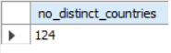

What country has the highest amount of debt?
SELECT
country_name, SUM(debt) as total_debt
FROM international_debt
GROUP BY country_name
ORDER BY total_debt DESC
LIMIT 1;

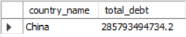

What country has the lowest amount of repayments?
(indicated by the "DT.AMT.DLXF.CD" indicator code)
SELECT
country_name,
indicator_name,
MIN(debt) AS lowest_repayment
FROM international_debt
WHERE indicator_code='DT.AMT.DLXF.CD'
GROUP BY country_name, indicator_name
ORDER BY lowest_repayment
LIMIT 1;

What are the Top 5 Countries by Total Debt (Principal + Interest)
SELECT
country_name,
SUM(debt) AS total_debt
FROM
international_debt
WHERE
indicator_code IN ('DT.AMT.DLXF.CD', 'DT.INT.DLXF.CD')
GROUP BY
country_name
ORDER BY
total_debt DESC
LIMIT 5;

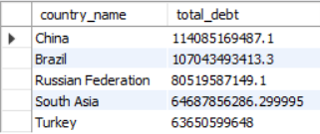

Average Debt by Debt Type
SELECT
indicator_name,
ROUND(AVG(debt), 2) AS average_debt
FROM
international_debt
GROUP BY
indicator_name
ORDER BY
average_debt DESC;
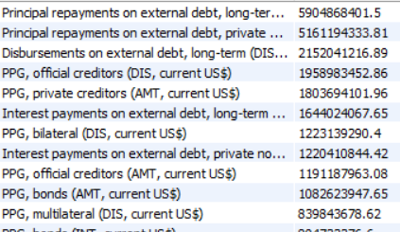

And more

Author: Owais Ali
Github Link: https://github.com/0waisAli

